GPCRs
G-protein coupled receptors (GPCRs) are one of the most common cell membrane receptors involved in intracellular signalling. The human genome codes for about 750 GPCRs, about 350 of which detect hormones, growth factors, and other endogenous ligands. The targets for 50% of FDA approved drugs are GPCRs (~10⁸ of them). The inactive GPCR (G-protein coupled receptor) consists of the ligand receptor $R$ and the G-protein trimer $G_{αβγ}$ in which the $G_{α}$ subunit binds GDP (guanosine diphosphate). This complex is labelled $R_{G}$ in Figure 1.1. When an extracellular ligand $L$ binds to $R_{G}$ (to form $R_{GL}$), the GDP in the $G_{α}$ subunit is rapidly exchanged for GTP (guanosine triphosphate), to form the active state of the receptor$R_{GLP}$. Note that intracellular GTP is 10 times more abundant than GDP. The active (GTP-bound) state of the receptor is unstable and dissociates into the ligand bound receptor ($R_{GL}$) and the two G-protein subunits $G_{α}GTP$ and $G_{βγ}$, both of which are intracellular signalling molecules. GPCR kinase (GRK) phosphorylates activated GPCRs to promote the binding of the arrestin protein to the receptor, internalising the receptor (removing it from the pool) and thereby preventing receptor binding of the G protein trimer. The key receptor states for GPCR signalling are shown in Figure H1.1, along with the reactions governing the transitions between these states.
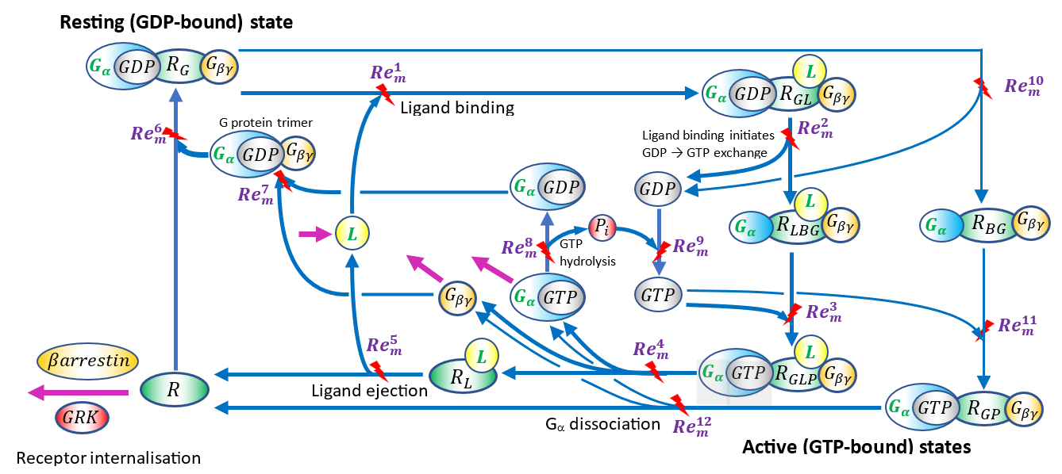
Figure 1.1 A model of the G-protein coupled receptor with 16 state variables and 12 reactions. Note that the input to this GPCR system is the flux of extracellular ligand $q_{o}^{L}$ and the outputs are the intracellular signalling molecules $q_{i}^{G_{α}GTP}$ and $q_{i}^{G_{βγ}}$ and the internalised receptor. Note that the $G_{α}$ protein is a GTPase (catalyses the hydrolysis of GTP to GDP). The return of GDP to GTP, depends on energy input by the ATP→ADP reaction.
A bond graph model of this biochemical reaction scheme is shown in Figure 1.2. Note that the goal is to define a GPCR module. The sharing of certain complexes (e.g., the G protein trimer) between adjacent receptors, and coupling to other processes such as receptor internalisation and adenylyl cyclase (for cAMP signalling) is not considered.
The equations associated with the bond graph model are generated by considering mass balance at the 0:nodes (shown in red, along with the chemical potentials $u_{location}^{species}$ in Figure 1.2) and energy balance at the 1:nodes (shown in green, along with the flows $v_{path}^{species}$). Every 0:node has a corresponding storage term $q_{location}^{species}$ for that molar species in which the relationship between molar amount (expressed in fmol) and chemical potential (J.mmol⁻¹) is given by the macroscopic Boltzmann relation $u_{location}^{species}=RT ln⁡\left(k_{species}q_{location}^{species}\right)$, where $RT$=2.5761 (J.mmol⁻¹) and $k_{species}$ (fmol⁻¹) is the thermodynamic constant for that species. Reactions, with potentials $u_{location}^{input}$ and $u_{location}^{output}$ , are defined by the Marcelin-deDonder formula $v_{reaction}^{species}=κ_{reaction}\left(e^{u_{location}^{input}/RT}-e^{u_{location}^{output}/RT}\right)$, where $κ_{reaction}$ is the kinetic parameter (fmol.s⁻¹).

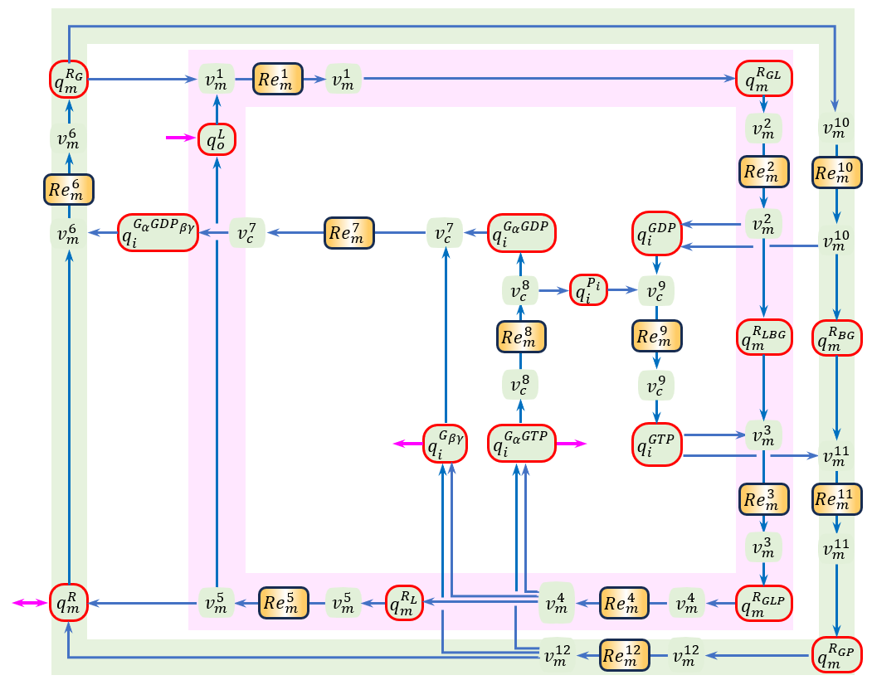
Figure 1.2 A bond graph model of the GPCR reactions shown in Figure 1.1. Note that there are 16 potentials corresponding to the 16 state variables, and a further 12 potentials needed for the 12 reactions. There are 12 flow variables associated with the 12 reactions.

Mass balance equations:
$\frac{d}{dt}\left[\begin{matrix}\begin{matrix}q_{o}^{L} \\ q_{m}^{R_{G}} \\ q_{m}^{R_{GL}}\end{matrix} \\ \begin{matrix}q_{m}^{R_{LBG}} \\ q_{m}^{R_{GLP}} \\ q_{m}^{R_{L}}\end{matrix} \\ \begin{matrix}q_{m}^{R} \\ q_{i}^{G_{α}GDP} \\ \begin{matrix}q_{i}^{G_{α}GTP} \\ \begin{matrix}q_{i}^{G_{βγ}} \\ q_{i}^{GDP} \\ q_{i}^{GTP}\end{matrix} \\ \begin{matrix}q_{i}^{G_{α}{GDP}_{βγ}} \\ \begin{matrix}q_{i}^{P} \\ q_{m}^{R_{BG}} \\ q_{m}^{R_{GP}}\end{matrix}\end{matrix}\end{matrix}\end{matrix}\end{matrix}\right]=$ $\left[\begin{matrix}\begin{matrix}\begin{matrix}v_{m}^{1} \\ v_{m}^{2}\end{matrix} \\ \begin{matrix}v_{m}^{3} \\ v_{m}^{4}\end{matrix}\end{matrix} \\ \begin{matrix}\begin{matrix}v_{m}^{5} \\ v_{m}^{6}\end{matrix} \\ \begin{matrix}v_{i}^{7} \\ \begin{matrix}v_{i}^{8} \\ \begin{matrix}\begin{matrix}v_{i}^{9} \\ v_{i}^{10}\end{matrix} \\ \begin{matrix}v_{i}^{11} \\ v_{i}^{12}\end{matrix}\end{matrix}\end{matrix}\end{matrix}\end{matrix}\end{matrix}\right]+\left[\begin{matrix}\begin{matrix}v_{input}^{L} \\ 0 \\ 0\end{matrix} \\ \begin{matrix}0 \\ 0 \\ 0\end{matrix} \\ \begin{matrix}v_{io}^{R} \\ 0 \\ \begin{matrix}-v_{output}^{G_{α}GTP} \\ -v_{output}^{G_{βγ}} \\ \begin{matrix}\begin{matrix}0 \\ 0\end{matrix} \\ \begin{matrix}0 \\ \begin{matrix}0 \\ 0 \\ 0\end{matrix}\end{matrix}\end{matrix}\end{matrix}\end{matrix}\end{matrix}\right]$
-1 |  |  |  | 1
-1 |  |  |  |  | 1 |  |  |  | -1
1 | -1
 | 1 | -1
 |  | 1 | -1
 |  |  | 1 | -1
 |  |  |  | 1 | -1 |  |  |  |  |  | 1
 |  |  |  |  |  | -1 | 1
 |  |  | 1 |  |  |  | -1 |  |  |  | 1
 |  |  | 1 |  |  | -1 |  |  |  |  | 1
 | 1 |  |  |  |  |  |  | -1 | 1
 |  | -1 |  |  |  |  |  | 1 |  | -1
 |  |  |  |  | -1 | 1
 |  |  |  |  |  |  | 1 | -1
 |  |  |  |  |  |  |  |  | 1 | -1
 |  |  |  |  |  |  |  |  |  | 1 | -1

where the $q_{location}^{species}$ terms have units of moles and the flow terms $v_{path}^{species}$ are in fmol.s⁻¹.
Note that a check on mass conservation for each chemical species gives:
Receptor: $\frac{d}{dt}\left(q_{m}^{R_{G}}+q_{m}^{R_{GL}}+q_{m}^{R_{LBG}}+q_{m}^{R_{GLP}}+q_{m}^{R_{L}}+q_{m}^{R}+q_{m}^{R_{BG}}+q_{m}^{R_{GP}}\right)=0$ 🗸 (sum of rows 2,3,4,5,6,7,15,16)
$G_{α}$: $\frac{d}{dt}\left(q_{m}^{R_{G}}+q_{m}^{R_{GL}}+q_{m}^{R_{LBG}}+q_{m}^{R_{GLP}}+q_{i}^{G_{α}GDP}+q_{i}^{G_{α}GTP}+q_{i}^{G_{α}{GDP}_{βγ}}+q_{m}^{R_{BG}}+q_{m}^{R_{GP}}\right)=0$ 🗸 (sum of rows 2,3,4,5,8,9,13,15,16)
$G_{βγ}$: $\frac{d}{dt}\left(q_{m}^{R_{G}}+q_{m}^{R_{GL}}+q_{m}^{R_{LBG}}+q_{m}^{R_{GLP}}+q_{m}^{G_{βγ}}+q_{i}^{G_{α}{GDP}_{βγ}}+q_{m}^{R_{BG}}+q_{m}^{R_{GP}}\right)=0$ 🗸 (sum of rows 2,3,4,5,10,13, 15,16)
$Guanosine$: $\frac{d}{dt}\left(q_{m}^{R_{G}}+q_{m}^{R_{GL}}+q_{m}^{R_{GLP}}+q_{i}^{G_{α}GDP}+q_{i}^{G_{α}GTP}+q_{i}^{GDP}+q_{i}^{GTP}+q_{i}^{G_{α}{GDP}_{βγ}}+q_{m}^{R_{GP}}\right)=0$ 🗸 (sum of rows 2,3,5,8,9,11,12,13,16)
Ligand: $\frac{d}{dt}\left(q_{o}^{L}+q_{m}^{R_{GL}}+q_{m}^{R_{LBG}}+q_{m}^{R_{GLP}}+q_{m}^{R_{L}}\right)=0$ 🗸 (sum of rows 1,3,4,5,6)
Phosphate: $\frac{d}{dt}\left(q_{m}^{R_{GLP}}+q_{i}^{G_{α}GTP}+q_{i}^{GTP}+q_{i}^{P}+q_{m}^{R_{GP}}\right)=0$ 🗸 (sum of rows 5,9,12,14,16)

The chemical potentials for the 16 state variables are given by the Boltzmann equations:
$u_{location}^{species}=RTln(K_{location}^{species}.u_{location}^{species})$
where the units of the thermodynamic $K_{location}^{species}$ terms are fmol⁻¹, and $u_{location}^{species}$ and $RT$ are J.mmol⁻¹.
The energy balance equations are:
($v_{m}^{1}$) $u_{1}^{f}=u_{m}^{R_{G}}+u_{o}^{L}$; $u_{1}^{r}=u_{m}^{R_{GL}}$; ($v_{m}^{2}$) $u_{2}^{f}=u_{m}^{R_{GL}}$; $u_{2}^{r}=u_{m}^{R_{LBG}}+u_{i}^{GDP}$;
($v_{m}^{3}$) $u_{3}^{f}=u_{m}^{R_{LBG}}+u_{i}^{GTP}$; $u_{3}^{r}=u_{m}^{R_{GLP}}$ ($v_{m}^{4}$) $u_{4}^{f}=u_{m}^{R_{GLP}}$; $u_{4}^{r}=u_{m}^{R_{L}}+u_{i}^{G_{α}GTP}+u_{i}^{G_{βγ}}$;
($v_{m}^{5}$) $u_{5}^{f}=u_{m}^{R_{L}}$; $u_{5}^{r}=u_{m}^{R}+u_{o}^{L}$; ($v_{m}^{6}$) $u_{6}^{f}=u_{m}^{R}+u_{i}^{G_{α}{GDP}_{βγ}}$; $u_{6}^{r}=u_{m}^{R_{GM}}$
($v_{i}^{7}$) $u_{7}^{f}=u_{i}^{G_{α}GDP}+u_{i}^{G_{βγ}}$; $u_{7}^{r}=u_{i}^{G_{α}{GDP}_{βγ}}$; ($v_{i}^{8}$) $u_{8}^{f}=u_{i}^{G_{α}GTP}$; $u_{8}^{r}=u_{i}^{G_{α}GDP}+u_{i}^{P}$;
($v_{i}^{9}$) $u_{9}^{f}=u_{i}^{GDP}+u_{i}^{P}$; $u_{9}^{r}=u_{i}^{GTP}$; ($v_{i}^{10}$) $u_{10}^{f}=u_{m}^{R_{G}}$; $u_{10}^{r}=u_{i}^{GDP}+u_{m}^{R_{BG}}$;
($v_{m}^{11}$) $u_{11}^{f}=u_{m}^{R_{BG}}+u_{i}^{GTP}$; $u_{11}^{r}=u_{m}^{R_{GP}}$; ($v_{m}^{12}$) $u_{12}^{f}=u_{m}^{R_{GP}}$; $u_{12}^{r}=u_{m}^{R}+u_{i}^{G_{α}GTP}+u_{i}^{G_{βγ}}$.
The flows through each of the 12 reactions are specified in terms of the chemical potentials via the Marcelin-de Donder formula $v_{m}^{j}=κ_{j}\left(e^{u_{j}^{f}/RT}-e^{u_{j}^{r}/RT}\right)$ for $j=1..12$., where $κ_{j}$ is the reaction rate in units of fmol.s⁻¹.

